
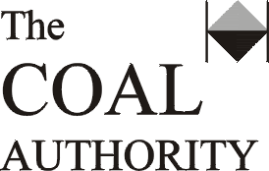
Interpretation Report on the Fluid Conductivity/ Temperature Logging and Discrete Water Sampling of
the East of Wear Shafts

thinking beyond construction

